Robot v1.27

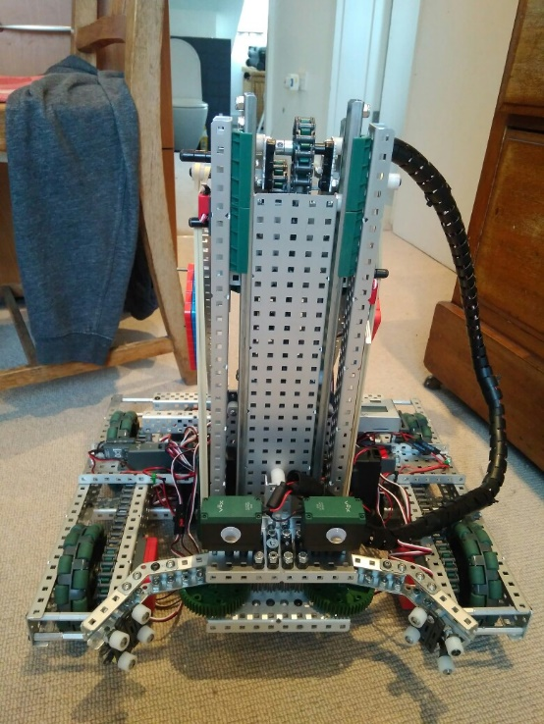

**Specification:**

* 6 Motor HS drive
* 2 drive chains
* 4 wheels
* Aluminium structure
* 4 motor lift
* 3 stage lift
* 2 motor claw

**Dimensions:**

* 17.5” x 15” x 17.5” when not extended

Logged by Robbie Buxton

30/07/2017 – 20:36

**Overview:**

The robot is now nearly ready to enter the full programming phase as most of the engineering work is complete. The first things we added today were two limit switches allowing us to program the lift to cut out at the minimum and maximum heights and an integrated motor encoder enabling us to implement PID control to the lift. We also added a Potentiometer to the claw so we can later also implement PID control there. The next thing we did was to rebuild the claw. We removed the standoffs and replaced them with spacers on tank tread which are far better at gripping the cone. We still need to add the module to the claw to manipulate mobile goals however since they still haven’t arrived yet we need to wait until they arrive before we can accurately do that. The final thing we did today was to add rubber bands to assist the lift. This allows it to be faster and stronger when going upwards which is essential as our lift is multifunctional and needs to be able to lift a whole stack.

**What needs to be changed:**

* Add mobile goal manipulator element to claw
* Program PID control
* Add stabilisers

**Changes Made:**

* Added integrated motor encoders
* Added two limit switches to the lift
* Remade the claw
* Put number plates in a better position
* Added elastic bands to assist lift.
* Added Potentiometer to the claw